SmartCare v0.3 - Domain Model Workbook
Simplified Student Resource
Week 6 | Domain Modelling

Requirement-to-Concept Trace
Requirement | Concept | State/behaviour | Decision
Duplicate appointment bookings occur | Appointment | I will make sure the system checks that no existing appointment shares the same practitioner and time slot before creating a new one. | I am adding a uniqueness check when creating an appointment against the practitioner's schedule.
Difficulty locating patient records | Patient | I will assign a unique ID to every patient along with clear, searchable fields (name, DOB, contact details). | I am giving each patient a unique ID and explicit fields instead of storing info as free text.
Inconsistent appointment status information | Appointment | I am limiting appointment statuses to a fixed set: Booked, Confirmed, Cancelled, Completed, or No-show. | I am modeling status as an enumeration to enforce valid status changes.
Limited visibility of practitioner availability | Practitioner | I am giving practitioners a way to list and expose their available time slots for easy booking checks. | I am adding availability checks directly to the practitioner for v1, while keeping a separate Schedule class as an optional future idea.
Manual cancellation processes | Appointment | I am adding a cancel() action that updates the status to Cancelled and records details. | I am placing the cancellation logic directly inside the Appointment concept.
Lack of reliable appointment history | Appointment | I am keeping finished and cancelled appointments in the system rather than deleting them. | I will never hard-delete appointments so I can preserve full history for audits and reports.
Difficulty producing basic operational reports | Patient, Practitioner, Appointment | I will pull totals and summaries (like appointments by status or date) directly from our core data. | I am skipping a dedicated Reporting class for v1 and querying the core objects instead.
System should initially stay simple | Clinic | n/a – provides context, not object state | I am excluding Clinic as a separate class for v1 to keep the model lightweight and focused.
Clinic provides consultations through practitioners (GPs) | Practitioner | Represents a GP delivering consultations. | I am modeling Practitioner generically for v1 (representing GPs) and will only subclass if new roles appear later.
Patients need to book consultations with practitioners | Patient, Appointment, Practitioner | Booking creates a new Appointment that links one Patient and one Practitioner. | I am setting up Patient 1 -- 0..* Appointment and Practitioner 1 -- 0..* Appointment relationships.

CRC Cards

Patient
Responsibilities | Collaborators
• Maintain my own details (name, DOB, phone, address)  • Request and initiate my own appointment bookings | Appointment
• Provide a reliable, searchable record  • View my past appointment history | Appointment

Practitioner
Responsibilities | Collaborators
• Maintain my available consultation time slots  • Accept and confirm appointment requests | Appointment
• Deliver consultations  • Share my availability so I don't get double-booked | Appointment

Appointment
Responsibilities | Collaborators
• Record which patient and practitioner are involved, plus the date/time  • Track and update my own status (Booked, Confirmed, Cancelled, Completed, No-show) | Patient, Practitioner
• Prevent double-booking for the same practitioner and time slot
• Handle my own cancellation and keep a record for history

UML Class Diagram Description
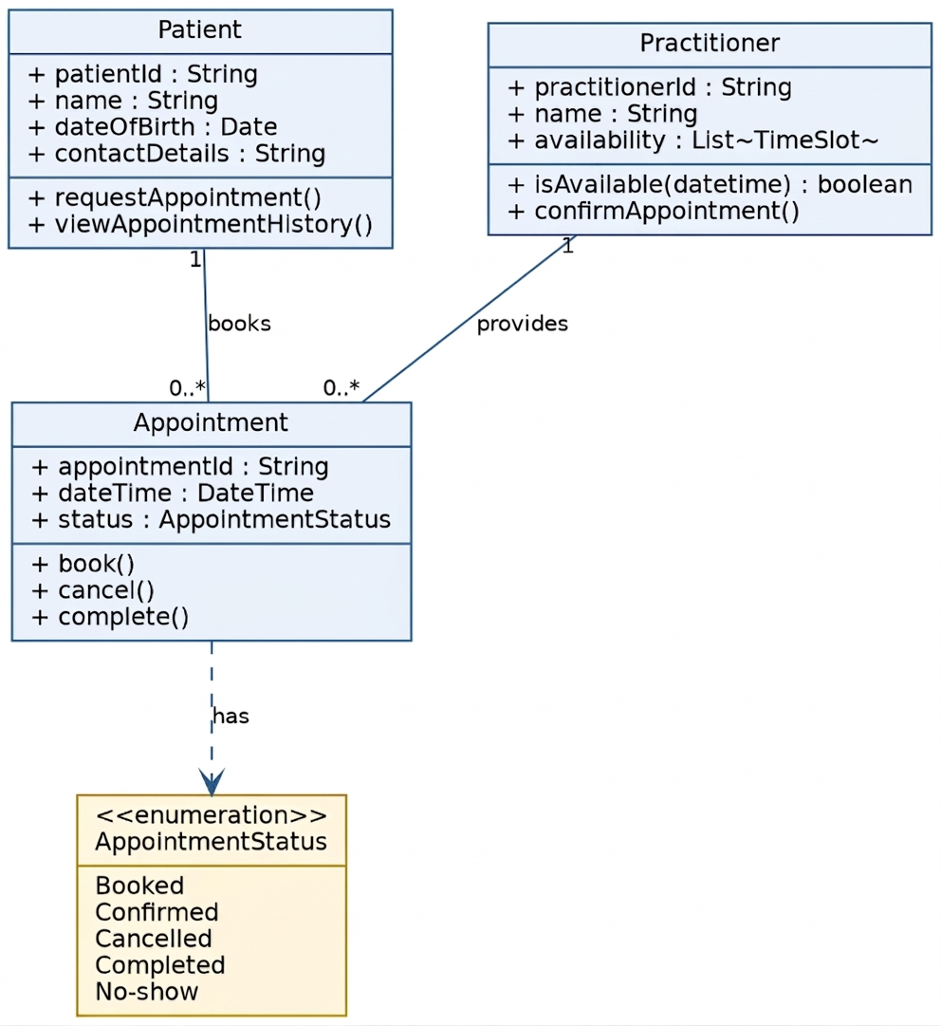

Design Rationale
I built my domain model around three main concepts: Patient, Practitioner, and Appointment. I chose these because every core issue in our system—like double bookings, missing history, and status confusion—comes down to how these three interact.
I made sure to place responsibilities directly where the data lives. For example, Appointment manages its own status and cancellation rules, which keeps business rules safe from outside interference. I linked Patient and Practitioner to Appointment using standard associations rather than strict ownership (composition) because an appointment references people without owning their life cycle.
Finally, I intentionally omitted a Clinic class for v1 because we only have one clinic, and adding it would create unnecessary complexity.

AI Design Review Record
AI suggestion | Evidence | Decision | Reason | Model change
Add PatientManager, PractitionerManager, AppointmentManager | Common AI pattern for service layers | Rejected | I felt this duplicated responsibilities that belong on the domain objects themselves. | None – kept logic inside domain classes.
Add ClinicController | No requirement for orchestrating classes | Rejected | This is an application layer concept, which is too early for my domain analysis. | Not added.
Add NotificationManager for reminders | No reminder requirement in v1 scope | Deferred | It's a great idea for later, but out of scope for our initial release. | Marked as a future enhancement.
Add ScheduleEngine for availability | Case study noted availability as a problem | Partially Accepted | A full engine is overkill right now, but simple availability tracking is useful. | Added as an optional Schedule concept instead of an engine.
Appointment inherits from Patient | Discussion on relationships | Rejected | An appointment is an action or interaction, not a type of person. | Modeled as an association (1 -- 0..*).

